The 19th International Symposium on Geo-disaster Reduction / High-Level Academic Forum on Disaster Mitigation and Integrated Risk Defense on the Plateau
(First Announcement)

11-16 July 2021, Xining, Qinghai Province, China

To discuss the hot issues in the field of geological disaster reduction, and promote the regional and global geological disaster prevention and mitigation activities, the International Consortium on Geo-disaster Reduction (ICGdR), Qinghai Normal University/Academy of Plateau Science and Sustainable, People’s Government of Qinghai Province & Beijing Normal University, China will jointly host the 19th International Symposium on Geo-disaster Reduction (19th ISGdR)/High-Level Academic Forum on Disaster Mitigation and Integrated Risk Defense on the Plateau on 11-16 July 2021 in Xining, Qinghai Province, China. This symposium will be jointly organized by the Research Center of Plateau Disaster Reduction and Emergency Management, Academy of Disaster Risk Science, Beijing Normal University, College of Geography Science, Qinghai Normal University, Disaster Reduction Center of Qinghai Province, Qinghai Geographical Society, and co-sponsored by the Qinghai Geographical Information Society and Qinghai Provincial Key Laboratory of Geospatial Information Technology and Application. Researchers, engineering technicians, legislators and administrators in the field of geological disaster reduction, integrated risk assessment and defense, environmental earth sciences are welcome to participate the symposium.
Symposium theme and Topics

Theme:
Geological disaster and integrated risk defense

Topics:
- Formative mechanism and environment of geological disasters;
- Recognition and early warning technology of geological disasters;
- Risk assessment and prevention planning of geological disasters;
- Geological disaster control and geological environment protection;
- Practice of geological disaster prevention and mitigation and regional sustainable development.

Scale, Date and Venue

Scale:
About 100 on-site participants.

Date: 11-16 July 2021
Registration: 11 July 2021
Presentations: 12 July 2021
Field trip: 13-15 July 2021

Venue
Academic Lecture Hall of Qinghai Normal University Library (Xining, Qinghai Province, China)

Accommodations
Xinchunlan International Hotel (No.20 Chaoyang West Road, Chengbei District, Xining, Qinghai Province, China, 0971-492888)

Organizers and Co-Organizers

Organizers:
International Consortium on Geo-disaster Reduction (ICGdR);
Qinghai Normal University/ Academy of Plateau Science and Sustainable, People’s Government of Qinghai Province & Beijing Normal University, China;
Tongji University;
Emergency Management Department of Qinghai Province;
International Institute for Space Planning and Sustainable Development

Co-organizers:
Research Center of Plateau Disaster Reduction and Emergency Management;
Academy of Disaster Risk Science, Beijing Normal University;
College of Geography Science, Qinghai Normal University;
Disaster Reduction Center of Qinghai Province;
Qinghai Geographical Society;
Qinghai Geographical Information Society;
Qinghai Provincial Key Laboratory of Geospatial Information Technology and Application.

Organizing Committee

1. Advisory committee
Co-Chairs：
Peng CUI (Academician of CAS / ICGdR Adviser)
Manchao HE (Academician of CAS / ICGdR Adviser)
Jianbing PENG (Academician of CAS / ICGdR Adviser)
Members:
Jingshan BO (President of Institute of Disaster Prevention, China)
Scott F. BURNS (Former President of International Association for Engineering Geology and the Environment (IAEG))
Paolo CANUTI (Director of UNESCO Chair in University of Florence, Italy)
Xiuli DU (Vice president of Beijing University of Technology, China)
Qunli HAN (Executive Director, Integrated Research on Disaster Risk)
Runqiu HUANG (Minister of Environment Protection of the P. R. China)
Zhilin LI (Honorary Dean of Faculty of Geosciences and Environmental Engineering, Southwest Jiaotong University, China)
Dwikorita KARNAWATI (Head of the Agency for Meteorology, Climatology and Geophysics of the Republic of Indonesia)
Shengli MA (Director of Institute of Geology, China Earthquake Administration)
Lei NIE (Professor of Jilin University, China)
Bin SHI (Professor of Nanjing University, China)
Peijun SHI（President，Qinghai Normal University；President，Academy of Plateau Science and Sustainability；Professor of Beijing Normal University，China）
Alexander STROM (Geodymanics Research Center, Russia)
Baitao SUN (Director of Institute of Engineering Mechanics, China Earthquake Administration)
Huiming TANG (Vice President of China University of Geosciences, Wuhan, China)
Gangalal TULADHAR (Chairman of Himalaya Conservation Group, Nepal)
Sijing WANG (Academician of Chinese Academy of Sciences)
Faquan WU (Secretary-General of IAEG)
Shuwen XING (Director of Institute of Geomechanics, Chinese Academy of Geological Sciences, China)
Weilin XU (Vice-President of Sichuan University, China)
Xiwei XU (National Institute of Natural Hazards, Ministry of Emergency Management of China)
Soichiro YASUKAWA (Programme Specialist, Coordinator for Disaster Risk Reduction and Resilience, Section on Earth Sciences and Geo-hazards Risk Reduction, Natural Sciences Sector, UNESCO)
Koetsu YAMAZAKI (President of Kanazawa University, Japan)
Yueping YIN (Deputy Director, China Geoenvironment Monitoring Institute, China Geological Survey)
Guodong ZHANG (Professor of China Three Gorges University)
Yangsheng ZHAO (Academician of Chinese Academy of Sciences; Professor of Taiyuan University of Technology, China)

2. Academic Committee
Co-Chairs：
Peijun SHI (Qinghai Normal University/ Academy of Plateau Science and Sustainability)
Fawu WANG (ICGdR President/Tongji University, China)
Zhenjiang SHEN (ICSPSD President/ Kanazawa University, Japan)
Members:
Netra Prakash BHANDARY (Ehime University, Japan)
Guangzhu CAO (Kunming University of Science and Technology, China)
Nicola CASAGLI (University of Firenze, Italy)
Ningsheng CHEN（Researcher，Institute of Mountain Hazards and Environment (IMHE), Chinese Academy of Sciences,）
Qiong CHEN（Assistant Professor of School of Geographic Sciences, Qinghai Normal University）
Qiangong CHENG (Southwest Jiaotong University, China)
Yifei CUI (Tsinghua University, China)
Sabatino CUOMO (University of Salerno, Italy)
Fuchu DAI (Beijing University of Technology, China)
Ranjan Kumar DAHAL (Tribhuvan University, Nepal)
Guoliang DAI (Southeast University, China)
Jianhui DENG (Sichuan University, China)
Teuku Faisal FATHANI (Universitas Gadjah Mada, Indonesia)
Louis GE (National Taiwan University, Chinese Taipei)
Hans-Balder HAVENITH (University of Liege, Belgium)
Siming HE (Institute of Mountain Hazards and Environment, CAS)
Yong HONG (Qingdao University of Technology, China)
Mingjian HU (Institute of Rock and Soil Mechanics, CAS)
Bolin HUANG (China Three Gorges University, China)
Yu HUANG (Tongji University, China)
Michel JABOYEDOFF (University of Lausanne, Switzerland)
Yonggang JIA (Ocean University of China)
Wenxing JIAN (China University of Geosciences (Wuhan))
Bok Chul KIM (Korea Institute of Geoscience and Mineral Resources)
Mikio KUBO (Study Group of Deformation Restraint by Geosynthetics, Japan)
Hengxing LAN (Institute of Geographic Sciences & Natural Resources Research (IGSNRR), CAS)
Tonglu LI (Chang’an University, China)
Qinhua LIANG (Hebei University of Engineering, China)
Chun LIU (Tongji University, China)
Fenggui LIU (Academy of Plateau Science and Sustainability, China / School of Geographic Sciences, Qinghai Normal University, China)
Jianhui LONG (Taiyuan University of Technology, China)
Masakatsu MIYAJIMA (Kanazawa University, Japan)
Sandro MORETTI (University of Firenze, Italy)
Agus Setyo MUNTOHAR (Universitas Muhammadiyah Yogyakarta, Indonesia)
Tingkai NIAN (Dalian University of Technology, China)
Shengwen QI (Institute of Geology and Geophysics, CAS)
Wenhao QI (Institute of Engineering Mechanics, CEA)
Wei SHAN (Northeast Forestry University, China)
Jun SHEN (China Institute of Disaster Prevention)
Jusong SHI (China Geological Survey)
Wanghua SUI (IMWA China National Commission)
Ping SUN (Institute of Geomechanics, CAGS)
Shuheng SUN (Liaoning Investigation Institute of Hydrogeology and Engineering Geology, China)
Chao-Sheng TANG (Nanjing University, China)
Binod TIWARI (California State University Fullerton, USA)
Isakbek TORGOEV (Institute of Geomechanics and Mining, National Academy Sciences of the Kyrgyz Republic)
Vít VILIMEK (Charles University in Prague, Czech Republic)
Huabin WANG (Huazhong University of Science and Technology, China)
Shimei WANG (China Three Gorges University)
Patrick WASSMER (Laboratoire de Géographie Physique, Meudon / University of Strasbourg, France)
Mike WINTER (Winter Associates, UK)
Qingbai WU (Cold and Arid Regions Environmental and Engineering Research Institute, CAS)
Aiguo XING (Shanghai Jiao Tong University, China)
Hong SUN (Shanghai Jiao Tong University, China)
Qiang XU (Chengdu University of Technology, China)
Chong XU (National Institute of Natural Hazards, Ministry of Emergency Management of China)
Yan XU (Jilin University, China)
Xin YAO (Institute of Geomechanics, CAGS)
Jianhong YE (Institute of Rock and Soil Mechanics, CAS)
Weimin YE (Tongji University, China)
Masaho YOSHIDA (Fukui College, National Institute of Technology, Japan)
Renmao YUAN (Institute of Geology, China Earthquake Administration)
Qiang ZHANG (Beijing Normal University, China)
Qiang ZHOU (School of Geographic Sciences, Qinghai Normal University, China）

3. Organizing Committee
Co-Chairs：
Fenggui LIU (Academy of Plateau Science and Sustainability, China /School of Geographic Sciences, Qinghai Normal University, China)
Ningsheng CHEN (Institute of Mountain Hazards and Environment, CAS)
Qiang ZHANG (Qinghai Normal University, China)
Members:
Michele CALVELLO, Byung-Gon CHAE, Qiong CHEN, Yonggui CHEN, Zili DAI, Adam EMMER, Xuanmei FAN, Fikri FARIS, Settimio FERLISI, Ying GUO, Wei HU, Toshikazu IKEMOTO, Ping LI, Ko-Fei LIU, Renqi LU, Wuwei MAO, Baicheng NIU, Dario PEDUTO, Yuko SARIKAWA, Manita TIMILSINA, Veronica TOFANI, Nicola TROCCOLI, Yufeng WANG, Xingshneg XIA, Hufeng YANG, Qingqing YANG, Yingbin ZHANG, Hu ZHENG, Qiang ZHOU
Secretariat member:
Zili DAI, Haixin GAO, Cunxiu LI, Baicheng NIU, Nansha SUN, Wanxai TIAN, Shengzhen WANG, Xingsheng XIA
Symposium agenda
1. 11 July 2021: Registration
2.12 July 2021: Opening ceremony and Lectures
3. 13-15 July 2021: Field trip
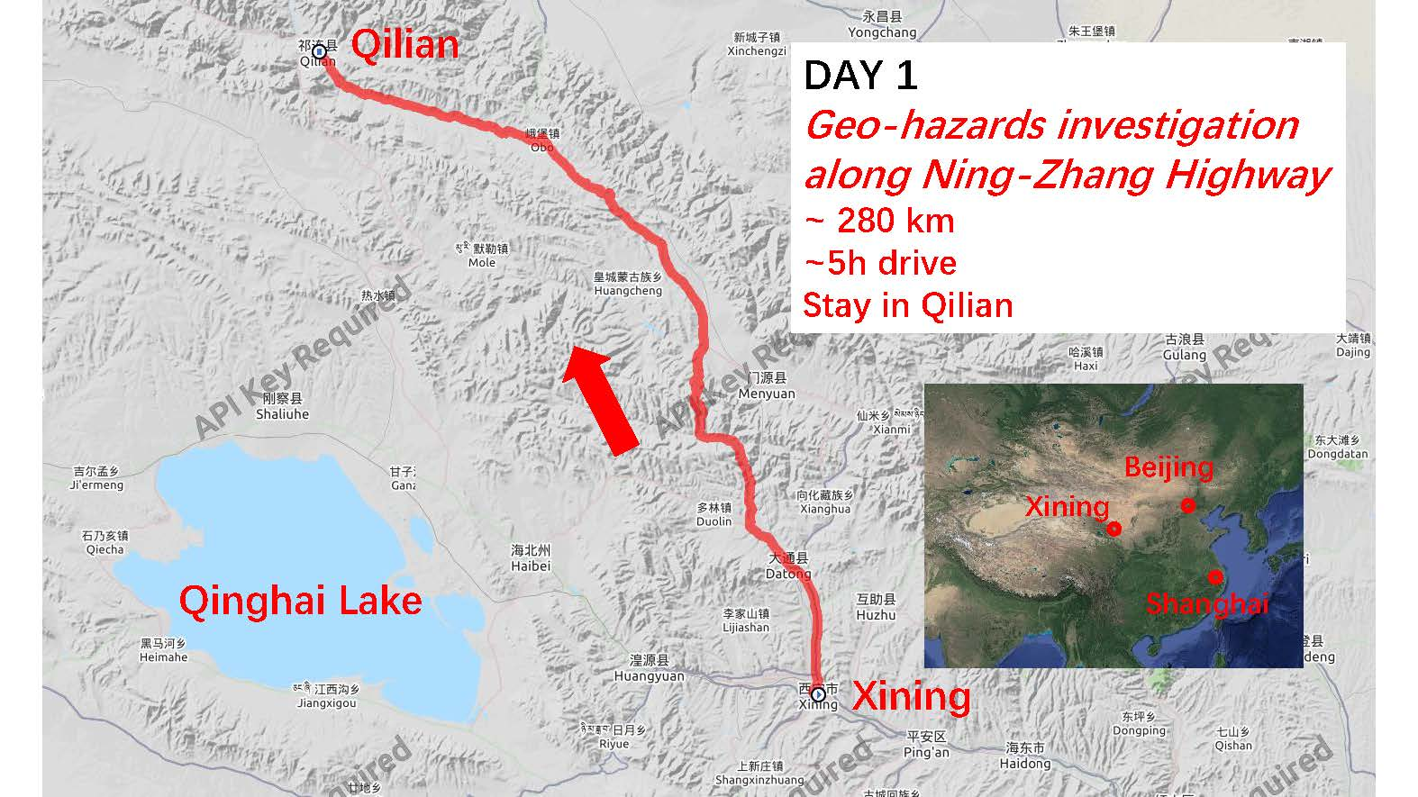
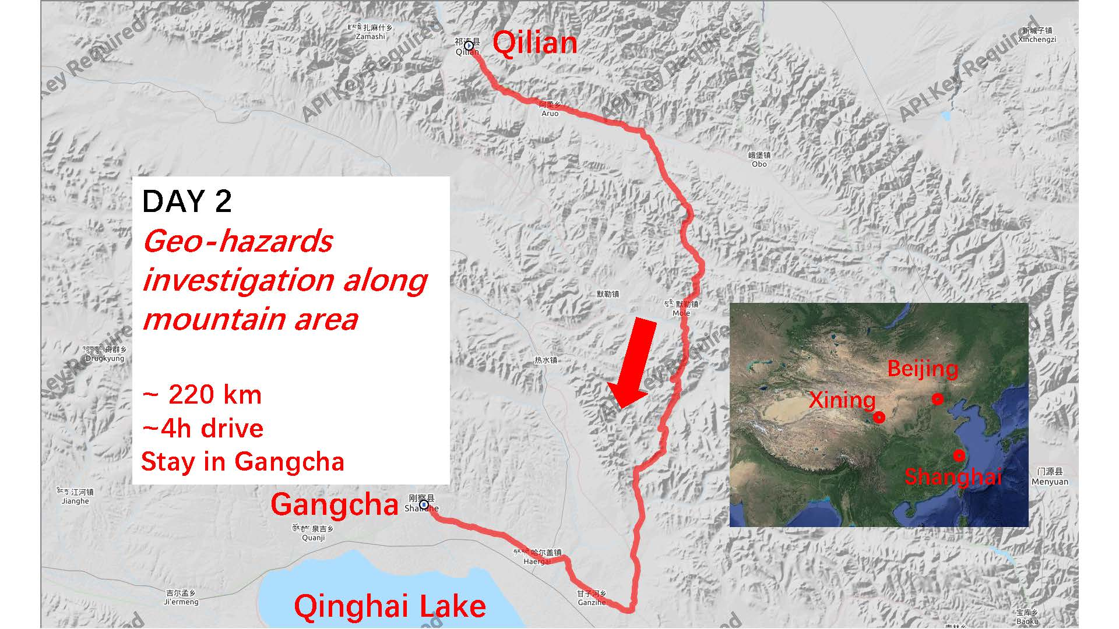
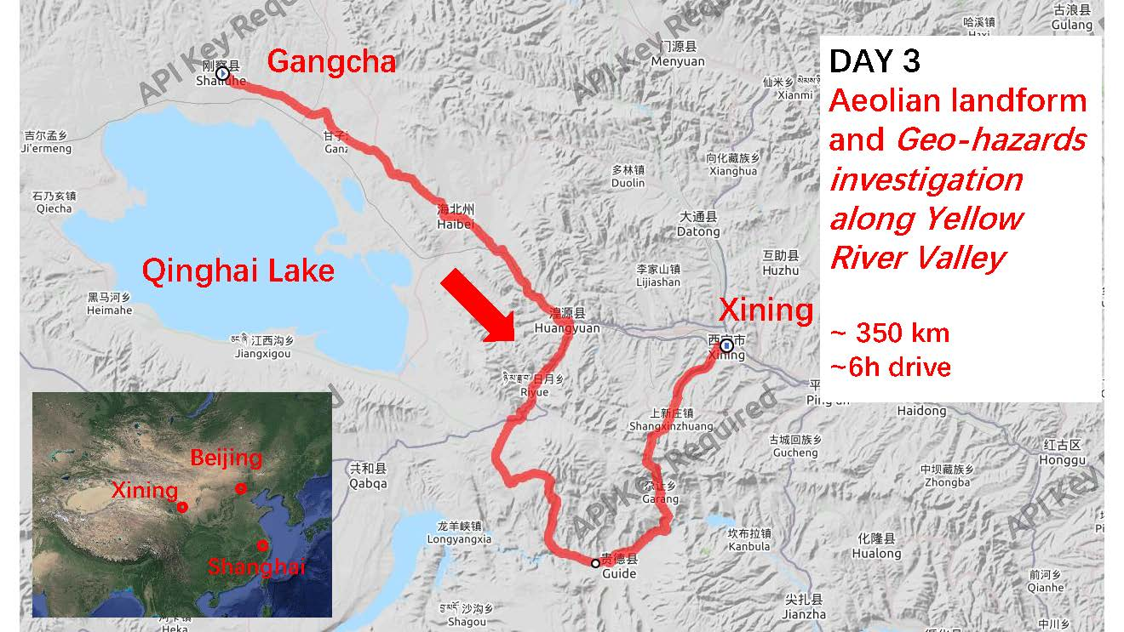

Registration
1. Participation intent to the 19ISGdR:
Please send the participation intent form below to gjjzhy2021@163.com no later than 15 June 2021.

Participation intent
Name: |  | Title: | Mr./ Ms./ Dr./ Prof.
Mobile Phone: |  | Email:
Affiliation:
Participation Form: | □ Online*  □ On-site | Presentation: | Poster/ Oral
Presentation title:
Participation to the field trip | YES or NO (please select one)
Accompanying person (if you have) | Name: Mobile phone:
*Only ICGdR members outside of Mainland of China can apply on-line presentation.

2.Abstract submitting deadline:
Please send the Abstract to gjjzhy2021@163.com no later than 30 June 2021.

3. ICGdR award application：
The application should be submitted to yhuang@tongji.edu.cn no later than 25 June 2021.

4. Registration fee
General on-site participants: 1200 RMB
ICGdR on-site Members: 1000 RMB
Students on-site: 600 RMB
On-line presentation: Free
Note: the on-site registration fee includes the expense of attending license, documents, and dining during the symposium.

5. Participation fee for field trip
All participants: 1800 RMB/person
Note: the participation fee covers the expense of food, hotel and bus transportation during the three-day field trip.

Contact us
Xingsheng XIA; Haixin GAO (Oral and Postal Presentation)
Tel: +86 15201047894 E-mail: gjjzhy2021@163.com
Zili DAI (ICGdR)
Tel: +86 18817879593 E-mail: zilidai@shu.edu.cn
Baicheng NIU; Shengzhen WANG (Abstract)
Tel: +86 18193122085 E-mail: gjjzhy2021@163.com
Qinqin LI; Cunxiu LI (Field trip)
Tel: +86 13541391070 E-mail: 381007941@qq.com
Qinqin LI (Registration and Hotel booking)
Tel: +86 13541391070 E-mail: 381007941@qq.com

